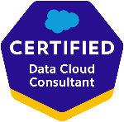
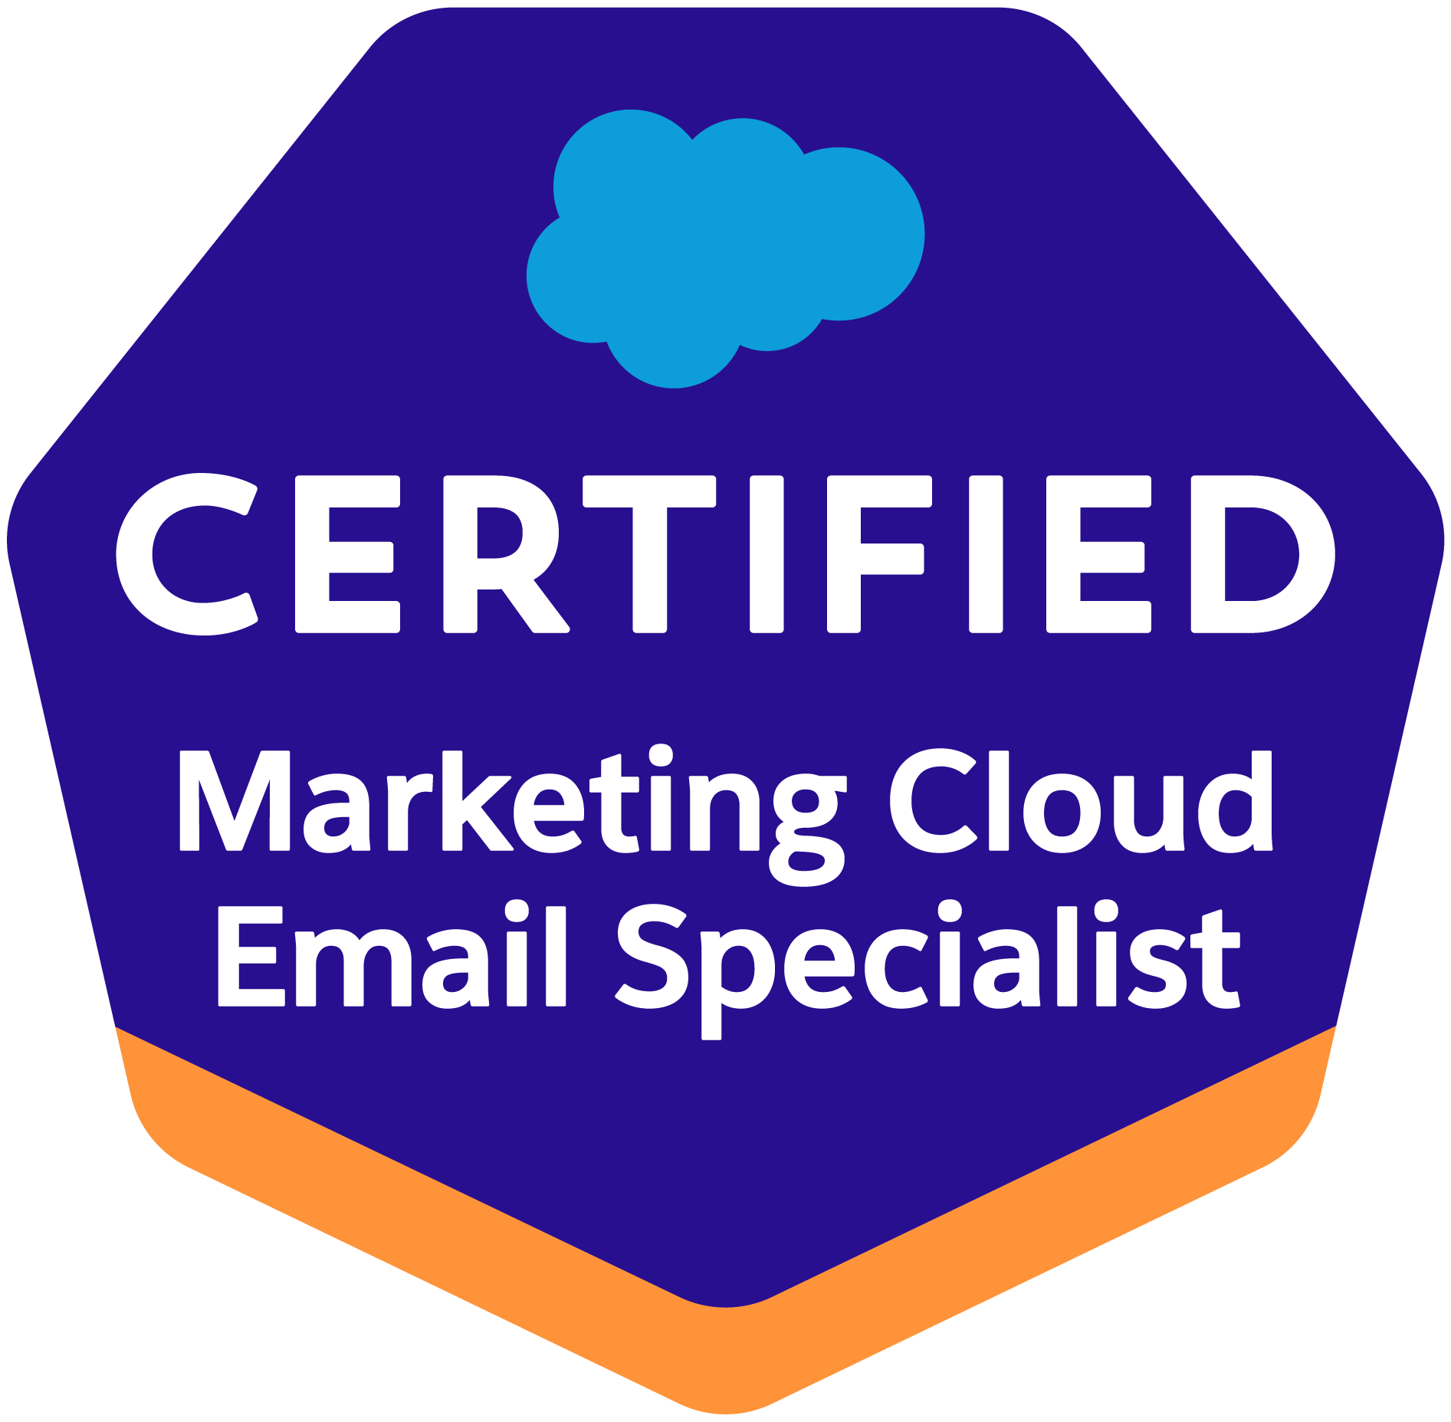
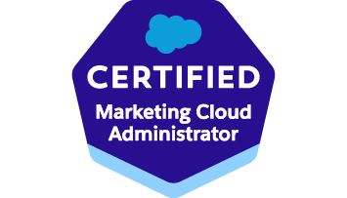

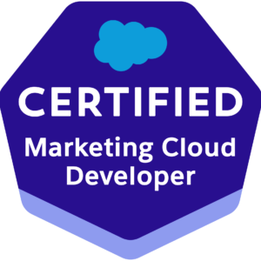

RAM PRASAD
Salesforce Marketing Cloud & Data Cloud Consultant
Hyderabad, India | +91 8073796731 | rammc296@gmail.com

PROFESSIONAL SUMMARY
Salesforce Marketing Cloud and Data Cloud professional with 9+ years of IT experience, including 7+ years specializing in marketing automation, customer data platforms, and enterprise campaign management.Supported preparation of leadership presentations, status updates, and program communication decks. Experienced in designing scalable marketing solutions using Journey Builder, Automation Studio, Data Cloud, AMPscript, SQL, and API integrations.
Knowledge on Salesforce Marketing Cloud Next (Next-Gen) capabilities, including event-driven architecture, real-time customer engagement, and AI-powered personalization. Strong experience in leveraging Data Cloud for unified customer profiles, identity resolution, and calculated insights to enable advanced segmentation and activation.
Proven ability to lead complex implementations, stack migrations, and CRM integrations while enabling data-driven personalization, real-time decisioning, and omnichannel marketing across email, SMS, push, and emerging channels.

CORE EXPERTISE
- Salesforce Marketing Cloud Architecture
- Salesforce Data Cloud (CDP)
- Journey Builder & Automation Studio
- Email Studio & MobileConnect
- AMPscript, SSJS, SQL
- REST & SOAP API Integrations
- Marketing Cloud Connect (CRM Integration)
- Audience Segmentation & Personalization
- Campaign Automation & Lifecycle Management
- SFTP Integrations & Data Pipelines
- HTML5, CSS3, Responsive Email Development

PROFESSIONAL EXPERIENCE

Senior SFMC Developer – Cloud Peritus Technologies (PlayOn Sports)
Hyderabad | May 2025 – Present
- Led end-to-end SFMC stack migration (S7 → S12) including data model, automations, journeys, and integrations with zero data loss.
- Designed and executed Business Unit restructuring strategy aligned with enterprise data governance and security standards.
- Built API-driven migration utilities using REST/SOAP APIs for assets, data extensions, and automation activities.
- Implemented event-driven journeys using real-time data ingestion patterns (SFMC Next approach).
- Supported the development and execution of change management strategies for Marketing Cloud transformation initiatives
- Performed data model optimization in Contact Builder to improve segmentation performance and reduce query time.
- Established pre- and post-migration validation frameworks ensuring campaign accuracy and data integrity.
- Collaborated with cross-functional teams to define scalable architecture for omnichannel engagement.
- Introduced automation monitoring and alerting mechanisms to reduce campaign failures.
- Supported Organizational Change Management (OCM) activities for business transformation and system implementation projects.
- Assisted in stakeholder analysis, impact assessments, and change readiness evaluations to ensure smooth user adoption.
- Optimized SQL queries and automations, improving processing efficiency by 30–40%.
- Led knowledge transfer sessions and mentored junior developers on SFMC best practices and Next-gen capabilities.

Lead Engineer – Brillio Technologies (Centene)
Hyderabad | Jun 2023 – Feb 2025
- Designed and executed large-scale healthcare campaigns (email + SMS) ensuring HIPAA-compliant data handling.
- Built advanced segmentation frameworks using SQL, Data Extensions, and behavioral data.
- Implemented personalization using AMPscript and dynamic content for patient engagement journeys.
- Developed end-to-end campaign lifecycle processes from audience creation to performance tracking.
- Integrated SFMC with external systems using REST APIs and SFTP-based data pipelines.
- Created campaign performance dashboards and automated reporting using SQL and data views.
- Worked closely with stakeholders to define customer journey orchestration strategies.
- Improved campaign engagement rates through A/B testing and optimization strategies.
- Supported Data Cloud integration use cases for unified customer profiles and activation.
- Ensured data quality and governance across multiple business units.

Senior Associate Technology – Publicis Sapient (Marks & Spencer)
Hyderabad | Nov 2022 – Jan 2023
- Developed and deployed responsive email campaigns aligned with brand and customer experience standards.
- Built automation workflows for scheduled and triggered marketing communications.
- Created SQL-based reporting and analytics solutions for campaign insights.
- Integrated SFMC with third-party systems using API-based data exchange mechanisms.
- Configured user roles, permissions, and security models for multi-region teams.
- Supported campaign QA, UAT, and production releases ensuring zero defects.
- Collaborated with business teams for requirement gathering and solution design.
- Enhanced email deliverability by implementing best practices in sender authentication and content optimization.

Salesforce Marketing Cloud Developer – Infosys
Bangalore | Apr 2021 – Oct 2022
- Developed triggered and batch campaigns using Journey Builder and Automation Studio.
- Built highly personalized email templates using AMPscript, SSJS, and dynamic content blocks.
- Configured Contact Builder data model including relationships and attribute groups.
- Implemented Marketing Cloud Connect for seamless CRM-SFMC data synchronization.
- Designed segmentation strategies using SQL and filtered data extensions.
- Automated data imports/exports using SFTP and file-based integrations.
- Supported real-time and near real-time campaign use cases.
- Troubleshot production issues and improved campaign reliability.
- Participated in end-to-end deployment lifecycle (Dev → QA → Prod).

Support Engineer – Customer Value Group Ltd
Bangalore | Feb 2019 – Feb 2020
- Executed and monitored email marketing campaigns using Email Studio and Journey Builder.
- Created segmentation queries and automation workflows for recurring campaigns.
- Managed user roles, permissions, and access controls.
- Handled campaign QA, validation, and deployment support.
- Resolved production issues and ensured minimal campaign downtime.
- Maintained data hygiene and validation processes across data extensions.
- Provided support for client requests, reporting, and campaign troubleshooting.

Senior Software Engineer – Conduent Technologies
Bangalore | June 2015 – Jan 2019
- Worked on data processing, ETL workflows, and campaign data preparation.
- Built and optimized SQL queries and stored procedures for large datasets.
- Supported marketing and customer communication systems.
- Participated in system enhancements and performance tuning.

SQL Developer – Trigent Software
Bangalore | Nov 2014 – June 2015
- Developed complex SQL queries, joins, and reporting logic.
- Worked on data validation, transformation, and migration tasks.
- Supported business teams with data extraction and reporting needs.

CERTIFICATIONS
- Salesforce Certified Marketing Cloud Email Specialist
- Salesforce Certified Marketing Cloud Developer
- Salesforce Certified Marketing Cloud Administrator
- Salesforce Certified Marketing Cloud Consultant
- Salesforce Certified Data Cloud Consultant
- Salesforce Certified AI Associate

EDUCATION
B.Tech – Nalanda Institute of Engineering & Technology, Andhra Pradesh (2012)

INTERESTS
Singing, Photography, Painting, Chess, Badminton

